HTN **“The objective of antihypertensive therapy should be to not only lower the blood pressure but to prevent the lethal and disabling cardiovascular sequelae.”**

Uncomplicated HTN = Thiazide: HTN as their primary medical condition

----systolic----------------------120------------------------------140------------------------------160----------------------------

Normal Pre-hypertension Stage 1 HTN Stage 2 HTN

----diastolic----------------------80--------------------------------90--------------------------------100--------------------------

Thiazide Thiazide + ACE

**Goal**: less than 140/90 mmHg

Why Thiazide as first line: Study

What is the study called? ALLHAD study Amlodipine Vs Linsinoprol Vs Doxazosin

Problem with Doxazosin? Alpha 1 blocker: 80% increase of heart failure, 20% stroke, CVD

Problem with Lisinopril? ACE-I 🡪 higher rate of stroke, HF and combined CVD

Problem with Amlodipine? Long acting Ca channel blocker 🡪 Higher rate of HF

Problem with Atenolol? (not in study) BB 🡪 increase risk of stroke

Complicated HTN: Problems such as

**Goal**: Less than 130/80 mmHg

What drugs to use?

1. MI Beta Blockers ACE or ARB
2. Coronary artery disease causes angina Beta Blockers ACE or ARB
3. Stroke Thiazide + ACE CCB
4. Left Ventricular Function Loop + ACE then add Beta Blocker
5. Diabetes ACE-I
6. Renal insufficiency ACE-I
7. CHF (not listed) spironolactone
8. Pre-Clampsia (not listed) IV Hydralazine (Direct Arterial Vasodilators), IV Labetalol

Drugs that Cause HTN

* + - Estrogens/Oral Contraceptives
    - Adrenal Steroids (ie prednisone, fludrocortisones)
    - Amphetamines/Cocaine
    - Oral decongestants/Anorectics (pseudophedrine, ephedra)
    - NSAIDS
    - MAO Inhibitors with tyramine containing foods
    - Venlafaxine b/c NE
    - Erythropoietin b/c build up of RBC
    - Cyclosporine and Tacrolimus
    - Ethanol
    - Dietary Supplements, ie Ephedra, Ma Huang

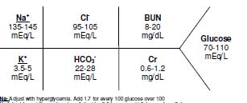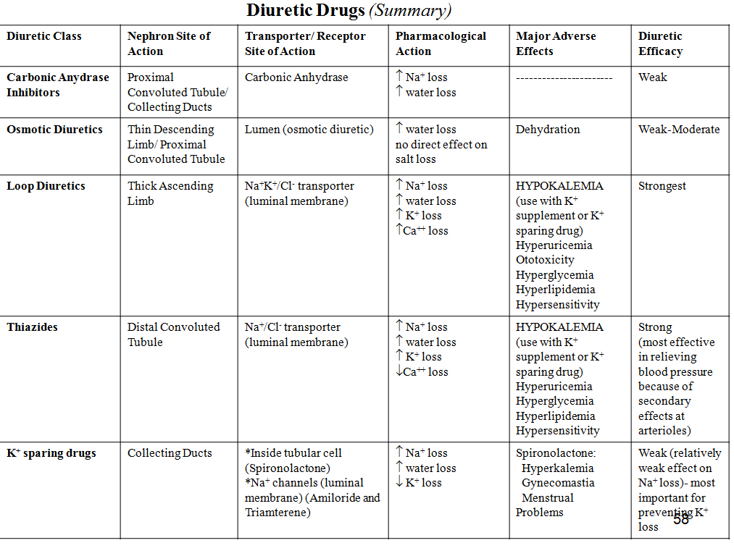

Thiazide Diuretic

All diuretics increase SCr. Why? low

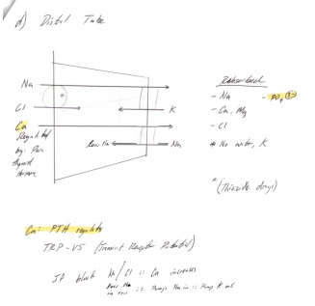**Mechanism**

1. Location? Distal tube
2. Block what channel? Na/Cl channel

**Use**:

1. Uncomplicated: First line in Uncomplicated HTN
2. What type of Complicated disease? Used to prevent reoccurring **stroke**
3. Treat Elderly with? isolated systolic hypertension
   1. Why? b/c there is less fluid (think about it)
   2. ISH is Defined as SBP? > 160 DBP <90 (normal)
4. Treat African Americans
   1. Why? b/c AA respond better to Thiazide and Ca channel blocker

**Drugs** dose?

Hydrochlorothiazide (Microzide) 12.5 – 25 mg/day

Chlorthalidone (Hygroton) 12.5 – 25 mg/day 2x more potent than HCTZ and longer duration

Indapamide (Lozol) 1.25 – 2.5 mg/day

**Pros**

1. Diuretic + Vasodilation
2. Synergy with ACE
   1. Why? Hydrochlorothiazide activates RAAS 🡪 ACE blocks RAAS
3. Useful in patients with osteoporosis
   1. 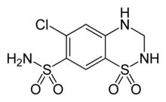How? Increasing Ca reuptake
4. More potent than Loops

**Cons**

1. HyPOkalemia
   1. Dose dependent 25 mg/d
   2. Causes what problem with Lithium? Decrease Li clearance (busy eliminating Na)
   3. Digoxin toxicity **Causes hypokalemia** 
      1. Mechanism? Block Na/K pump of heart
      2. How? *the ↓ in plasma K+ levels increases . the efficacy of digitalis because - *the lower plasma K+ . concentration makes it easier for cardiac glycosides to bind to . and block the Na+K+ pump. (K wants to leave more in order to . compensate for the loss of K outside)
2. Other low Electrolytes ____ Ca and Mg
3. Photosensitivity b/c of? (a structure) Sulfa
4. Dizziness for 2 weeks (transient)
   1. Why? Body tries to readjust

Loops aka ceiling diuretic low loop, low CrCl = use loop

**Mechanism**:

1. Location? thick ascending of the Loop of Henle
2. Channels? Na/K/Cl channel

**Use**

1. Treat what complicated disease? Left Ventricular Function

**Drugs dose?**

Furosemide (Lasix) 20-320 mg/day (flip)

Bumetanide (Bumex®) 0.5-4 mg/d in bid divided doses

Torsemide (Demadex®) 5-10 mg/daily

**Pros**

1. Patients with Low ClCr < _____ ml/min < 25-30 ml/min must use loop instead of Thiazide
   1. Why? Loop is closer than distal tube, loop reaches target easily

**Cons**

1. 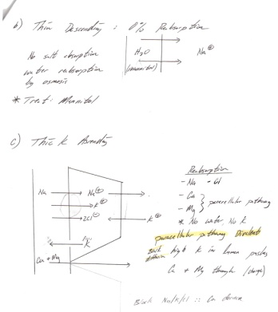Not as potent as Thaizide
   1. Why thiazide more potent? b/c thiazides also vasodilate
   2. Lower PVR Postvoid residual
2. HyPOkalemia
   1. Hypo lvl of Potassium < __ mEq/L < 3.5 mEq/L (normal is 3.5-5 mEq/L)
   2. Hypo leads to? Cardiac arrhythmias
      1. Treat? IV potassium
   3. Hypo Causes what problem with Lithium? Decrease Li clearance (busy eliminating Na)
   4. Digoxin toxicity **Causes hypokalemia** 
      1. Mechanism? Block Na/K pump of heart
      2. How? *the ↓ in plasma K+ levels increases . the efficacy of digitalis because - *the lower plasma K+ . concentration makes it easier for cardiac glycosides to bind to . and block the Na+K+ pump. (K wants to leave more in order to . compensate for the loss of K outside)
3. Decrease in what electrolyte? Calcium
4. Addition of NSAID 🡪 less antihypertensive
   1. Why? Inhibit prostaglandin (vasodilator) and increase Na retention

Potassium Sparing

**Mechanism**:

1. Mechanism of Spironolactone and Eplerenone? Aldosterone antagonists
2. Location: **intracellular** cytoplasmic receptor sites and collecting duct
3. 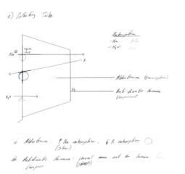Blocks what channel? Na of collecting duct

**Use**:

1. Treat hypokalemia
   1. Hypo = Level of potassium? < __ mEq/L < 3.5 mEq/L (normal is 3.5-5 mEq/L)
   2. Result of hypokalemia? Arrhythmia and funky EKG
      1. Treat? IV potassium
   3. Combination with what drug? Thiazide
2. When to use Spironolactone? Severe CHF
3. When to use Eplerenone? Patients who develop severe CHF as a result of MI

**Drugs**: dose?

Spironolactone (Aldactone) 25 – 50 mg/day

Triamterene (Dyrenium) 50 – 100 mg/day (tramp needs 50 cents)

Eplerenone (Inspra) 50 – 100 mg/day

**Pros**:

1. Increases potassium

**Cons**:

1. Not often effective for hypertension
2. Gynecomastia in spironolactone gynecomastia = boobies
   1. Why boobies? Antiandrogen effect

Beta Blockers

**Mechanism**

1. Binds to beta 1 receptors in heart
   1. Define Negatively Inotropic (Ionotropy) Agent that decreases contractility
   2. Define Negatively Chronotropic decrease HR chrono = time tropic=turn
2. Blocks renin release

**Use**

1. Uncomplicated MI and Coronary heart disease
2. Atrial tachycardia
3. Atrial Fib
4. Angina
5. Migrane

**Drugs dose?**

Atenolol (Tenormin) Renally elim 50 – 100 mg/day (divide BID) attend 50 to 100%

Acebutolol (Sectral) ISA 200 – 800 mg/day (divide BID) 2,8 acebutt str8 down

Metoprolol (Lopressor) 100 – 200 mg/day (divide BID) met = close 100 - 200

Carvedilol (Coreg) alpha and BB 6.25 – 50 mg/day (divide BID) skateboard = 6.25 to 50mm

ProPranolol (Inderal) 80 – 320 mg/day (divide BID) P = 8 propane **3**20

Labetalol indicated in pregnancy alpha and beta blocker

1. ISA drugs (Intrinsic sympathomimetic Activity
   1. What are the drugs? CAPP Carteolol, Acebutolol, Penbutolol, Pindolol
   2. Never use for CAD and MI patients
      1. Why? Partial agonist
   3. Use for? HTN and arrhythmias

Beta blockers cont.

**Pros**

1. Good in young b/c of more receptors
2. Good with diuretics

**Contraindications**

1. second degree heart block 🡪 HR below 55
2. third degree heart block 🡪 HR below 40

**Cons**

1. Bradycardia. Why? Too much beta blocking
2. Diabetes + BB = masked hypoglycemia
   1. Symptoms of hypoglycemia tremors, sweating
   2. Why BB mask? *BB blocks tremors* by decreasing epinephrine
3. Drug interactions
   1. DHP and Non-DHP CCB
      1. Why? Decrease HR
   2. Decongenstants. Why? Antagonize effect of beta blockers 🡪 raise BP
   3. Verapamil,Diltiazem (Ca channel blocker) risk of bradycardia
   4. NSAID blunt anti-HTN effect
   5. Digoxin bradycardia

ACE/ARB/Renin Inhibitors working on the RAAS System

**Mechanism**

1. ACE inhibits Angiotensin Convertin Enzyme
2. ARB inhibits Angiotensin II
3. ACE and ARBS dilate efferent arteriole & GFR
   1. Good: reduce hydrostatic pressure good for renal
   2. Bad: slight rise in SCr why? Low GFR 🡪 little filtered 🡪 Cr builds up 🡪 renal failure

**ACE Vs ARB**

1. Goal: primary composite outcome was ___ death from CV cause, MI, stroke, HF (heat failure)
2. ACE (Ramipril) Vs ARB (Telmisartan)
   1. Stats: 16.5% Vs 16.7%
   2. ARB: slightly lower BP and less cough
   3. ACE : Cheaper

**Use**

1. Treat what 2 Compelling indications DM and Renal insufficiency (be cautious)
   1. DM. why? decrease glucose reaching the kidney b/c of dilating efferent
   2. Renal insufficiency. Why? Dilate efferent 🡪 less pressure to kidney
2. Status Post MI
3. Reoccurrent stroke
4. CHG

**ACE-I Drugs**

Captopril (Capoten) 12.5 – 150 mg/day bid-tid

Enalapril (Vasotec) 2.5 – 40 mg/day daily-bid

Fosinopril (Monopril) 10 – 40 mg/day

Lisinopril (Prinivil, Zestril) 5 – 40 mg/day daily-bid

**ARB Drugs**

Losartan (Cozzar) 50 – 100 mg/day daily-bid

Candesartan (Atacand) 8 – 32 mg/day

Valsartan (Diovan) 80 – 320 mg/day

ACE-I and ARB cont

**Pros**

1. Good with white people (not AA)

**Contraindications**

1. Pregnancy 1st – 3rd trimester
   1. Category D
   2. Why? Limit blood flow to fetus

**Cons**

1. ACE causes cough. Why? Increase bradykinin levels by preventing its metabolism
   1. 10 – 15%
   2. Greater in AA and Asians. 3-4X more
   3. Treat? Decrease dose or switch to ARB
2. ACE-I and ARB
   1. Increase SCr. Why? Low GFR 🡪 little filtered 🡪 Cr builds up
   2. HyPERkalemia. Why? Reduction in aldosterone levels
      1. Levels greater than?___mEq/L 5 mEq/L
      2. If levels are >6 mEq/L
         1. What symptoms? EKG changes
         2. Treat?
            1. Beta agonist.why? (to move K inside skeletal muscle)
            2. Insulin why? stop beta cells from expelling K (beta cells usually keeps K . channel open. Close to depolarize)
            3. Calcium gluconate
      3. **Monitor: 2-4 weeks**
   3. Angioedema (rare) Why? believed that bradykinin induces COX activity -- increases . thromboxanes, leukotrienes and PGs -- PGs induce angioedema . (blood vessel swelling)

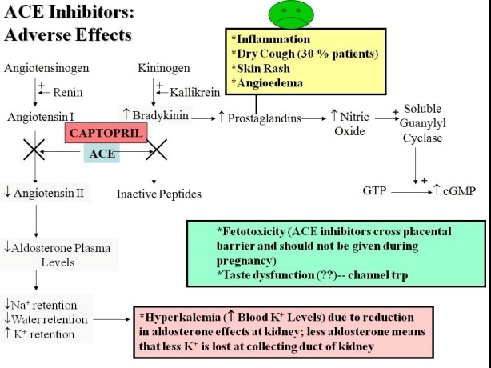

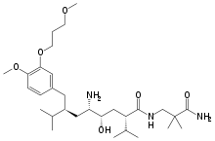Renin Inhibitor p30

**Mechanism**

1. Inhibit renin

Treat????????

**Drugs**

AliskiREN (Tekturna) 150 mg/day then titrate 2 weeks later to 300 mg/day

**Pros**

1. Decrease proteinuria

**Contraindications**

1. Angioedema??

**Cons**

1. hyPERkalemia
2. Decrease in furosemide (loop) levels
3. Don’t eat fatty meals

Non-DHP Calcium Channel blockers (CCB)

**Mechanism**

1. Inhibits transmembrane influx of extracellular Ca across myocardial and vascular SM cell

**Treat**

1. Second line for angina (coronary heart disease causes angina)
2. Diastolic dysfunction
3. Migraine
4. Chronic coronary disease
5. 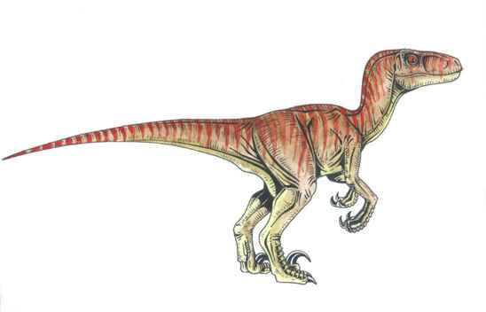Atrial tachycardia
6. Atrial fib
7. 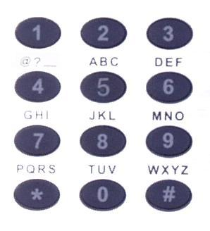Diabetes with proteinuria

**Drugs: Non-DHP**

Diltiazem CD (Cardizem) daily 120-540 daily

Verapamil SR (Calan®) 120-480mg/d in 1-2 divided doses

**Pros**

1. Decrease SA/AV node conduction
2. Decrease HR especially Verapamil
3. Decrease Cardiac contractility especially verapamil
4. Increase coronary blood flow
5. Effective in AA (not as much whites)

**Contraindication**

1. Don’t use when patient has heart block
   1. Why? CCB decreases SA/AV node conduction (slow electrical system)

**Cons**

1. Don’t take with Beta blockers
   1. Why? Increase risk of heart block-electrical system of the heart & bradycardia
   2. What drug then? DHP 🡪 Amlodipine,
2. Cardiac conduction abnormalities
   1. Bradycardia
   2. AV block. Why? CCB decreases SA/AV node conduction
3. Edema
   1. Why? vasodilation
4. Inhibit CYP2A**4** (especially verapamil)

DHP Calcium Channel blocker

**Mechanism**

1. Inhibits transmembrane influx of extracellular Ca across myocardial and vascular SM cell

**Treat**

1. Long acting treats older patients with ISH
   1. What Is ISH? Isolated Systolic hypertention
   2. Range? mmHg 190
2. Angina
3. NEVER USE IF ASSOCIATED WITH MI Nifedipine
4. NEVER USED FOR HTN nifedipine

**Drugs**

Amlodipine (Norvasc®) 2.5-10mg daily 2.5 of a friend

Felodipine (Plendil®) 5-20mg daily fel = five

Nifedipine XL(Adalat® CC) 30-120mg daily nife wu tang 30 chambers

**Cons**

1. Never with Beta blockers
2. Reflex tachycardia
   1. Why? because of their potent peripheral vasodilating effects
3. Non-pitting peripheral edema when pushed, will regain tension
   1. Why? b/c Natriuretic powerful vasodilator
4. Palpitations rapid, fluttering or pounding heartbeats.
5. HyPOtension
   1. Flushing
   2. HA, Lightheadedness

|  |  |  |  |
| --- | --- | --- | --- |
|  | **Verapamil** | **Diltiazem** | **Dihydropyridines** |
| Peripheral vasodilation | ↑ | ↑ | ↑↑ |
| Heart rate | ↓↓ | ↓ | ↑(reflex tachycardia;too much vasodilation) |
| SA/AV node conduction | ↓ | ↓ | 0 |
| Cardiac contractility | ↓↓ | ↓ | 0/↓* |
| Coronary blood flow | ↑ | ↑ | ↑↑ |

Alpha Blockers: Second Line Agent

**Mechanism**

1. Blocks alpha 1 receptors

**Treat: not effective as monotherapy**

1. HTN + BPH
2. HTN + PTSD post traumatic stress disorder

**Drugs**

Clonidine 0.1-2.4mg/d in 2 divided doses

Clonidine patch 0.1-0.3mg/24hr once weekly

**Cons**

1. Orthostatic HyPOtension
   1. How to avoid? Give HS
2. PDE-5 Inhibitor Drug Interaction
3. Abrupt discontinuation 🡪 HTN crisis

Direct Arterial Vasodilators: second line

**Mechanism**

1. Direct arterial SM relaxation and dilation

**Treat**: Not first line, not monotherapy

1. Useful for resistant HTN

**Drugs:**

Hydralazine 20-200mg/d in 2-4 divided doses hy = 2

Minoxidil

**Pros**

1. Decrease diastolic BP

**Cons**

1. SLE/Lupus
   1. Symptoms? Tiredness, pain
2. Reflex tachycardia
   1. Due to? Vasodilation
3. Sodium and water retention
   1. Treat? Diuretic

Terms

Resistant Hypertension:

1. No BP change: 3 medications at optimal dose
2. BP change: 4 or more medications

Hypertensive Crisis: over 180/120 mmHg

Hypertensive Urgencies: diastolic > 120 mmHg with NO organ damage

Treat:

1. Clonidine (alpha blocker) 0.1 – 0.2 mg PO
2. Captopril (ACE) 6.25 – 50 mg PO
3. Labetalol 200 – 400 mg PO

Hypertensive Emergency: diastolic > 120 mmHg WITH organ damage

Organs

1. Eyes: ocular hemorrhage
2. CNS: Dizziness, HA
3. Heart: LVH, edema, MI, unstable angina stable angina is angina w/ stress ; unstable angina is poor blood
4. 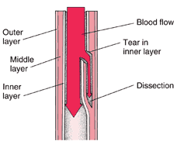Renal: Rise SCr

Aortic Dissection

MAP goal: < 80 mmHg

Systolic BP < 100 mmHg

IV therapy for hypertensive crisis

Sodium Nitroprusside

1. Mechanism: Arterial and Venous Vasodilator
2. Special conditions: Most hypertensive emergencies
3. Cons:
   1. Caution with intracranial pressure
   2. Contains Cyanide 🡪 Renal don’t use if patient has renal disease b/c it is elim renal

Nitroglycerin

1. Mechanism: venous dilator
2. Special conditions: Coronary ischemia chest pain b/c of reduced myocardial O2 consumption
3. Cons
   1. Tolerance with prolonged use

Nicardipine & dihydropyridine

1. Mechanism: Ca channel blocker
2. Special conditions Post operative HTN
3. Cons
   1. Reflex Tachycardia may lead to heart failure in patients with ischemic disease

Clevidipine

1. Mechanism: Newer Ca channel blocker
2. Special conditions post operative HTN
   1. More predictable than Nicardipine
3. Cons
   1. Egg or Soy allergy b/c drug has to be in emulsion (high triglycerides)